Learning activity 2

Evidence: Personal likes

I like swimming, because it helps improve breathing and is necessary for my professional profile.

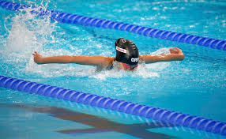

I like cats, because are very beautiful and playful.



I like skating, because I can improve coordination and concentration.

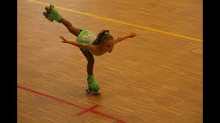

I like dogs, because are tender, playful they are an excellent company

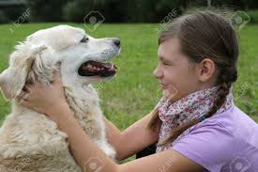

I like basketball, because is fun and develops a good physical condition.

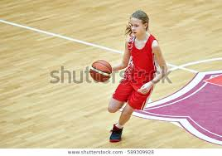

I like dolphin, because are beautiful and tender.

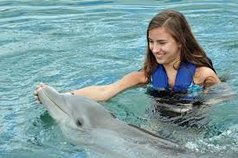

I like cycling, because helps the body to be in good condition physical

